**Subhan Bin Yousaf**

**Section B**

**481281**

**FOP Lab Manual 4**

**Lab Tasks**

**Lab Task 1 :**

#include <iostream>

using namespace std;

int main() {

int sum;

for(int i=1; i<=10; i++) {

sum = sum + i ;

}

cout << "The sum of 10 natural numbers is : "<< sum;

return 0;

}



**Lab Task 2 :**

#include <iostream>

using namespace std;

int main() {

int product ;

int number ;

cout << "Enter a number: " ;

cin >> number ;

for (int i = 1; i<=10; ++i) {

product = number*i ;

cout << number << " x " << i << " = " << product << endl ;

}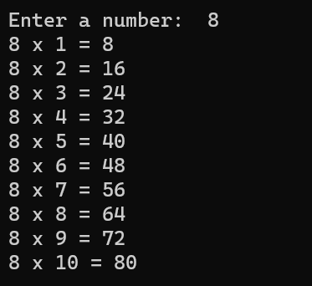

}

**Lab Task 3 :**

#include <iostream>

using namespace std;

int main() {

int a=1 ;

int b ;

int i ;

Cout << "Please write the number to calculate factorial of : " <<endl ;

Cin >> b ;

for( i=1 ; i<=b ; i++ ) {

a=a*i ;

}

cout << "the factorial of "<< b << " is "<< a << endl ;

return 0;

}

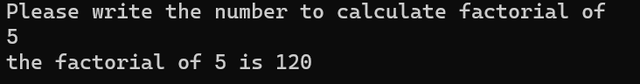

**Lab Task 4 :**

#include <iostream>

using namespace std;

int main() {

int a,b,c,d;

cout << "Enter first number " << endl;

cin >> a ;

cout << "Enter second term " << endl;

cin>>b;

cout << "How many terms would u like " << endl ;

cin>>c;

cout << endl;

cout<<a<<endl<<b<<endl;

for( int i=1; i<c-1; i++ )

{

d = a + b ;

a = b;

b = d;

cout<<d<<endl;

}

}

